Insect Model

Subject:  Related Subjects: | Grade Level(s):  Length of Lesson: | Type: Inquiry / Design / Project  Keywords:

Lesson Overview
Use this section to describe at a high level what the lesson is. Should be no more than 3-4 lines.

Lesson Focus
What is the central question or phenomenon being investigated? What problem are they trying to solve?

Lesson Objective(s) | State the objective of the lesson. Ideally one to two lines of what the lesson plan attempts to achieve.  This project will help students think creatively about form and function of organisms. Students will:  Learn about the different forms and functions of insects  Be able to predict how an insect might adapt fit its environment  Get a better understanding and intuition for evol/ution

Lesson Timing

5 minutes | Introduce the Lesson
30 minutes | ...

Materials | - Paper  - Aluminum Foil  - Plastic Forks  - Glue Guns  - Glue Slugs  - Tape  - Toothpicks  - Straw  - Rubber Bands  - Plastic Wrap  - Markers/Crayons/Colored Pencils
Instructor Prep | - Step 1
Related Resources | - List related lessons/ppts etc available from USC or outside, trusted orgs

Lesson Plan

Introduction
The students learned about the food chain; this week they will use their
knowledge to build a model of a hypothetical insect. All animals are formed differently
depending on the functions they need to survive. With regards to the food chain, this
means mouthparts and digestive organs must be properly fitted for the animal’s diet.
Additionally, the organism may feature body parts that help it avoid being eaten. We
look at insects, one of the most prolific of all animals, to find how they adapt to different
environments and different food chains.
Insects’ mouthparts are all similar yet different. They have the same general
parts of the mouth, but these parts vary depending on what the insect eats. For
example, insects that chew often have more defined mandibles to grind their food
before consumption. Insects like butterflies have developed a long proboscis that can
probe flowers and suck up the nectar through the tubes. Other insects like the housefly
have a sort of sucking mouthpart to suck up liquids. Furthermore, mosquitoes must be
able to pierce skin to suck up blood, so they have thin, tubular, serrated mouthpieces.
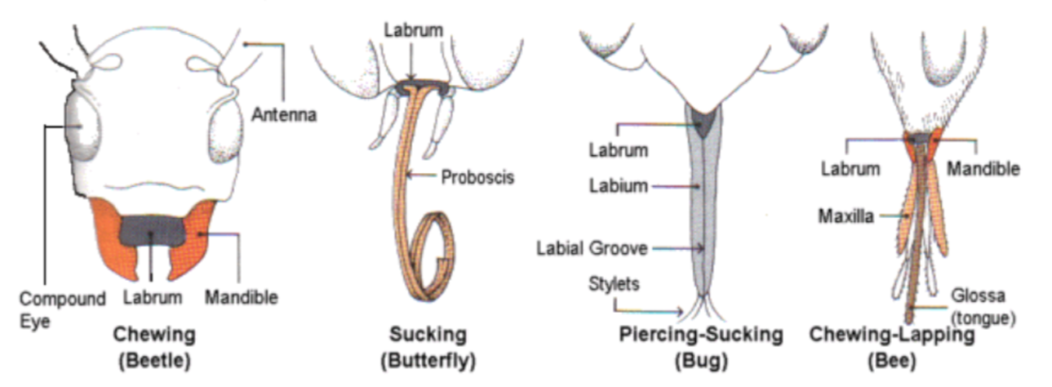

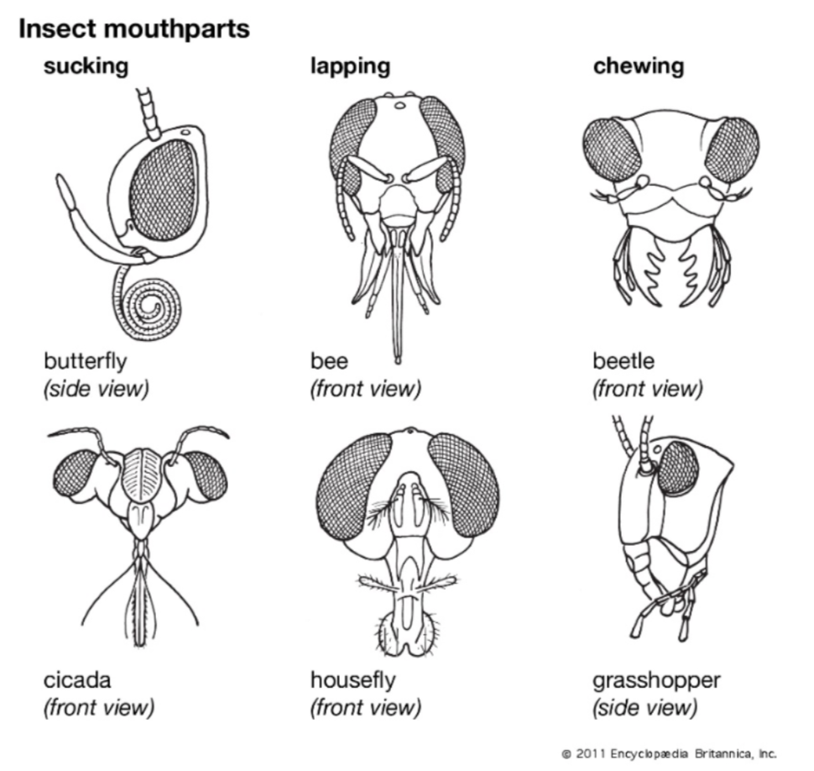

Procedure
1. The project begins with a lesson where I will introduce many different types of
insect mouthparts and their functions. I may also talk about how humans’ teeth
are formed specialized for different eating functions.
2. The students will form groups of three or four. Each group will be given a habitat,
a food, and a predator
3. The groups must first design their insect, keeping in mind its particular
environment.
4. If the design addresses the needs of their hypothetical insect, the students get
their supplies and start building models
5. Students must describe the form and function of their insects

Wrap-up
1) Do all animals eat the same things?
2) Are there some birds, fish, reptiles, and mammals that eat insects?
3) Do insects only eat plants?
4) Do all insects’ mouths look the same?

Lesson Background for Teachers

Suggested Real-World STEM Connections
- List possible related Role Models in STEM (with details and links to more reading). Give suggestions for examples of scientists/engineers who are from underrepresented groups in STEM in related careers.
- List related real-world engineering problems and examples

Lesson Variations and Options
Include descriptions of alternative methods or ways to present things.

Explanation
Describe the background concepts and explanations behind the lesson. This can be more in depth than a teacher/instructor would actually share with students.

Key Concepts and Vocabulary
- Word 1: Grade Appropriate Definition
- Word 2: Grade Appropriate Definition

Safety Notes
- Safety instruction

